- Click on Google Chrome icon on computer desktop.

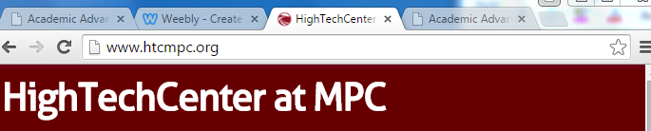
- High Tech Center website should be the home page. If it is not, type in the address below in the search box and click Enter.

- Click on the heading that says CAI Classes.

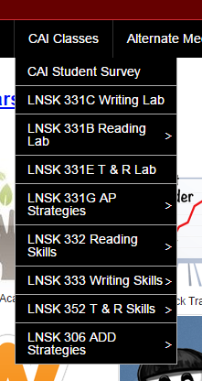
- A drop down menu appears that will have a list of classes taught in the CAI Lab. Select the class you want to look at and click on the page.

- Another drop down menu will appear with a list of the weeks of the semester. Click on the week you want to see.
